[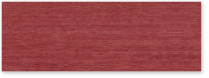](https://www.nanik.co.jp/img/products/colors/wing/0535.jpg)[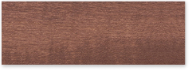](https://www.nanik.co.jp/img/products/colors/wing/0034.jpg)[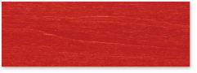](https://www.nanik.co.jp/img/products/colors/wing/0092.jpg)[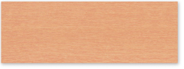](https://www.nanik.co.jp/img/products/colors/wing/0095.jpg)[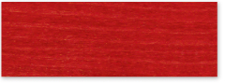](https://www.nanik.co.jp/img/products/colors/wing/0568.jpg)[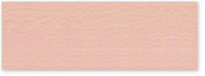](https://www.nanik.co.jp/img/products/colors/wing/0093C.jpg)  
[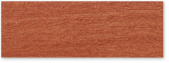](https://www.nanik.co.jp/img/products/colors/wing/0108.jpg)[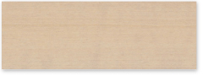](https://www.nanik.co.jp/img/products/colors/wing/0044.jpg)  
[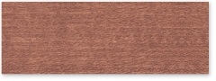](https://www.nanik.co.jp/img/products/colors/wing/0530.jpg)[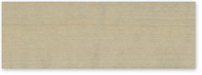](https://www.nanik.co.jp/img/products/colors/wing/0529.jpg)  
[](https://www.nanik.co.jp/img/products/colors/wing/0034.jpg)[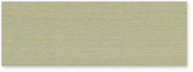](https://www.nanik.co.jp/img/products/colors/wing/0508.jpg)  
[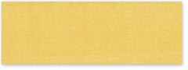](https://www.nanik.co.jp/img/products/colors/wing/0113.jpg)[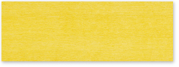](https://www.nanik.co.jp/img/products/colors/wing/0104.jpg)[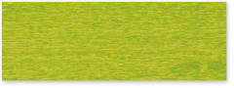](https://www.nanik.co.jp/img/products/colors/wing/0105.jpg)[](https://www.nanik.co.jp/img/products/colors/wing/0154.jpg)  
[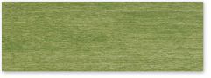](https://www.nanik.co.jp/img/products/colors/wing/0534.jpg)[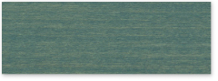](https://www.nanik.co.jp/img/products/colors/wing/0106C.jpg)

[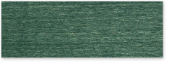](https://www.nanik.co.jp/img/products/colors/wing/0514.jpg)[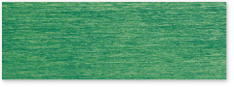](https://www.nanik.co.jp/img/products/colors/wing/0103.jpg)  
[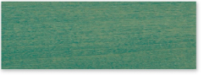](https://www.nanik.co.jp/img/products/colors/wing/0038.jpg)[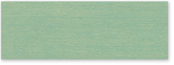](https://www.nanik.co.jp/img/products/colors/wing/0097.jpg)  
[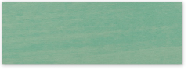](https://www.nanik.co.jp/img/products/colors/wing/0091.jpg)[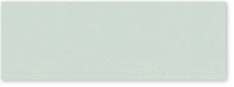](https://www.nanik.co.jp/img/products/colors/wing/0043.jpg)[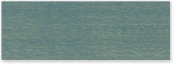](https://www.nanik.co.jp/img/products/colors/wing/0031C.jpg)[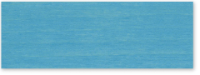](https://www.nanik.co.jp/img/products/colors/wing/0098.jpg)[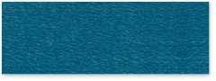](https://www.nanik.co.jp/img/products/colors/wing/0107.jpg)[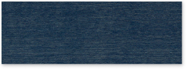](https://www.nanik.co.jp/img/products/colors/wing/0528.jpg)  
[](https://www.nanik.co.jp/img/products/colors/wing/0831.jpg)[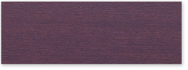](https://www.nanik.co.jp/img/products/colors/wing/0538.jpg)[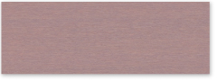](https://www.nanik.co.jp/img/products/colors/wing/0537.jpg)[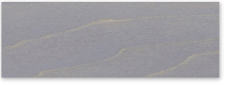](https://www.nanik.co.jp/img/products/colors/wing/0536.jpg)  
[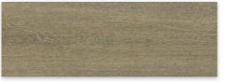](https://www.nanik.co.jp/img/products/colors/wing/0157.jpg)[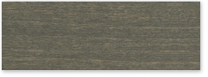](https://www.nanik.co.jp/img/products/colors/wing/0037.jpg)